The Civilian’s Dilemma: Civilians Exhibit Automatic Defensive Responses to the Police

Vincenzo J. Olivett¹ and David S. March¹

¹Department of Psychology, Florida State University

PREPRINT

In Press: Olivett, V. J. & March, D. S. (2023). The Civilian’s Dilemma: Civilians Exhibit Automatic Defensive Responses to the Police. Journal of Personality and Social Psychology.

Online First Version: https://doi.org/10.1037/pspi0000439

Author Note

Vincenzo J. Olivett ORCID ID: https://orcid.org/0000-0003-2140-1703

We declare no conflict of interest.

Correspondence for this article should be addressed to Vincenzo J. Olivett, Department of Psychology, Florida State University, 1107 W Call St, Tallahassee, FL, 32304. Email: olivett@psy.fsu.edu or march@psy.fsu.edu.
Abstract
Interactions between police officers and civilians incur for both police and civilians the possibility of danger due to a non-zero likelihood of encountering a physical threat. A body of work examining the implications of threat processes during police-civilian interactions focuses almost exclusively on the perspective of police officers, under the auspice that police use-of-force decisions stem from perceptions and misperceptions of threat (e.g., research on the shooter bias). Almost no research has examined these dynamics from the perspective of civilians whose encounter with police involve interacting with an armed and potentially dangerous individual. In the current work, we advance the idea that just as police may respond to civilians as threats, civilians may respond to the police as threats. That is, among civilians, encountering the police may evoke a combination of defensive bodily and behavioral responses. Across three studies (N = 603) each utilizing unique measures of defensive behavioral and physiological responding, we found that people more rapidly avoid police than non-police, demonstrate enhanced defensive freeze responses to police than non-police, and evince larger defensive physiological preparation towards police than non-police. In light of these patterns, we discuss the implications of defensive responses for shaping civilian behavior in real-world encounters with the police.

But Lyoya also might have believed his best option was to flee… maybe he’s thinking to just escape a situation that’s threatening. - On the fatal shooting of Patrick Lyoya by a police officer

The Civilian’s Dilemma: Civilians Exhibit Automatic Defensive Responses to the Police
Interactions between police officers and civilians incur for both police and civilians the possibility of danger due to a non-zero likelihood of encountering a physical threat. Like all potentially threatening situations, police-civilian interactions may evoke physiological and behavioral responses geared toward self-defense (Mobbs et al., 2020). From a police officer’s perspective, encountering a civilian may mean exposure to a potentially dangerous (e.g., armed, or otherwise violent) individual. Researchers have therefore suggested that officer’s threat perceptions (or misperceptions) and associated defensive responses can in some cases promote use of force. For example, research has shown that certain racial and ethnic groups in the US are more strongly linked to the concept danger and may evoke a threat response (e.g., Black Americans, March et al., 2021; March, 2022; Hispanics, March & Graham, 2015), and research on the “shooter bias” implies that associations inaccurately and disproportionally linking certain racial and ethnic groups to danger facilitate ostensibly defensive but sometimes biased behavioral responses (e.g., shooter bias, Correll et al., 2002, 2007).
From the civilian’s perspective, encounters with police officers (in the US) are certain to involve exposure to armed and potentially injurious individuals. Just as perceiving a human threat may encourage defensive responses among police officers, police-threat perceptions among civilians may sometimes result in associated defensive behavioral responses. Supporting the idea that encountering police may activate threat processes is our recent work showing that people automatically associate the police with physical threat (Olivett & March, 2021). Building on those associations, the current work furthers the idea that civilians may not only perceive police officers as a physical threat but may also respond defensively to the threat. In other words, although our earlier work found an automatic police-threat association, whether people evince automatic defensive behaviors remains unknown. The current work tests this important and timely question. We begin by describing human threat responses and how they are typically measured and describe the parallels for such responses in police-civilian encounters. We then present three studies testing whether people exbibit heightened threat responses to the police.
Behavioral and Physiological Responses to Threat
When faced with threats to survival, humans exhibit bodily and behavioral reactions tailored to minimize physical harm. These include responses characterized by initial changes in peripheral physiology (e.g., changes in heart rate, sweat release, muscular preparation) as well as downstream defensive physical behaviors (LeDoux & Pine, 2016; Löw et al., 2008). In humans, perceiving a threat promotes canonical responses including active avoidance (i.e., fleeing the danger), defensive aggression (i.e., fighting the danger), and/or defensive immobilization (i.e., freezing to minimize detection and/or prepare for future action; Roelofs & Dayan, 2022). In a given situation, the most adaptive response is determined by both proximity of the threat and whether there exists opportunity for escape (Fanselow & Lester, 1988; Löw et al., 2008; Mobbs et al., 2020). Escape is often the ideal alternative; but a closer proximity threat may necessitate defensive aggression. If one is yet undetected by the threat or needs more time to determine the most effective action, freezing to minimize detection can be the most effective means of survival.
Laboratory studies exploring the human threat response use measures that attempt to analog naturalistic defensive behavioral responses seen in the real-world. These measures are designed to capture a distinct aspect of the threat response. For example, research on escape shows that “flee” behaviors indicated via keyboard responses are accompanied by changes in heart rate, electrodermal activity, and other physiological responses (Löw et al., 2015; Mobbs et al., 2007). This work indicates that the body is preparing to engage or is currently engaging in a defensive (in this case, avoidant) behavioral response. Other work on avoidance has used joystick (push/pull; avoid/approach) tasks to mimic an escape behavior by allowing people to distance themselves from certain types of stimuli. In these tasks, the content of the stimuli is secondary to the task and people are instead tasked with avoiding all stimuli of a certain shape or border color. Even though the presence of a threat is task-irrelevant, people more rapidly “avoid” threatening than nonthreatening visual stimuli. For example, people more rapidly avoid angry faces than neutral faces (Heuer et al., 2007; Marsh et al., 2005) and spiders than butterflies (Klein et al., 2011). Here the possibility of escape leads to faster movement initiating avoidance of threat stimuli.
Defensive freezing in humans is often assessed by measuring whole-body postural sway (i.e., how much and in what directions peoples’ body weight naturally and automatically shifts while standing upright with feet shoulder-width apart). Postural sway is captured using a stabilometric force platform that continuously records a standing person’s center of pressure along the anterior-posterior (i.e., forward-backward) and mediolateral (i.e., side-to-side) planes. Posture increases in stability along the mediolateral relative to anterior-posterior plane when feet are stationed at roughly shoulder-width. Therefore, greater range in movement the AP plane renders AP-SD more susceptible to affective modulation (Roelofs et al., 2010). Indicating enhanced defensive freeze (Roelofs, 2017), people evince reduced anterior-posterior bodily sway in anticipation of electric shock (Gladwin et al., 2016; Hashemi et al., 2019; van Ast, et al., 2021) and while viewing human and non-human threats (Azevedo et al., 2005; Bastos et al., 2016; Roelofs et al., 2010). Here, the body is inhibiting movement for potential defensive (e.g., to minimize detection) and information seeking (e.g., to plan escape) purposes.
A direct measure of defensive physiological responding is the startle-eyeblink paradigm which utilizes a noise-blast (i.e., startle probe) to induce an eyeblink during (typically visual) stimulus processing. Facial electromyography (fEMG) measures blink amplitude by recording electrical potential generated by the orbicularis oculi muscle responsible for closing the eye (Grillon et al., 1991; Lang et al., 1990). The amplitude of the startle-eyeblink is an index of the threat response where relatively larger blinks reflect enhanced muscular preparation for defense during exposure to threat versus nonthreat. Here the body is responding to the presence of a threat by preparing the muscles to engage in defensive behaviors. That defensive behavior is ultimately elicited by the noise-probe which induces an eyeblink designed to protect the body from harm. Recent research has shown that threatening stimuli evoke larger startle eyeblinks than do positive, neutral, and even nonthreatening-negative stimuli regardless of whether stimuli are presented above or below the level of conscious perception (March et al., 2017; 2022)
Defensive Responses During Police-Civilian Encounters
Defensive responses, like those described above, are hypothesized to affect outcomes upon encountering members of groups stereotyped as dangerous (e.g., March et al., 2021). Much thought has been devoted to highlighting the ostensible role of group-based threat perceptions in police-civilian interactions. Indirect evidence for the influence of threat during police interactions with civilians comes from work using the first-person shooter task (FPST; Correll et al., 2002; Kahn & Davies, 2011). On the FPST, people are often (a) faster to “shoot” armed Black than White men and (b) slower to “not-shoot” unarmed Black than White men. Experimentally activating Black-danger or Black-weapon associations leads to increased anti-Black shooter bias (Correll et al., 2007). Although not direct evidence for a threat response per se, the activation of a threat association is thought to promote shoot responses and, consequently, it has been suggested that officer’s reactions during police-civilian interactions may at least be partially defensive and driven by perceiving (or misperceiving) a threat.
The same cultural socialization processes that promote stereotypes linking certain racial or ethnic groups to threat may likewise promote the learning of associations linking the police with threat (Hamilton & Sherman, 1994). Even absent personal experience, vicarious exposure to pervasive examples of police violence in the U.S. (i.e., by directly witnessing, or watching news coverage of police officers inflicting physical harm) may result in socially fear-conditioned associations linking police with threat (Olsson et al., 2007; Olsson & Phelps, 2004; Olsson & Phelps, 2007). Indirectly supporting this idea are findings demonstrating that exposure to media coverage of police violence is linked to self-reported emotional fear responses (Campbell & Valera, 2020). Our recent work also suggests that people automatically associate police versus non-police (e.g., casually dressed civilians and uniformed non-police professionals such as firemen) with “dangerous” more than with “safe” or even “negative” (Olivett & March, 2021). Furthermore, these effects may manifest uniquely across certain racial and ethnic groups. For example, Black Americans are both perhaps more likely than other racial and ethnic groups to perceive the police as a threat, and more likely to experience contact with the police (Crutchfield et al., 2012). Indirectly supporting this idea, recent research finds that more pronounced self-reported fear of police among Black versus White Americans is mediated by heighted neighborhood visibility of the police (Pickett et al., 2022).
Yet a police-threat association is not the same as a police-threat driven defensive response. An association is a mental representation and a necessary prior to a response. A threat response involves physiological and behavioral reactions geared toward self-preservation. Although evidence of a police-threat association is telling, people can exert control to behave in a manner inconsistent with the automatically activated attitude (i.e., by effortfully overcoming the influence of automatic processes; Devine et al., 2002). Yet threat evoking stimuli are preferentially processed and likely to activate associations that influence behaviors with relatively little opportunity to intervene (March et al., 2018a, 2018b). Consequently, police-threat associations may evoke defensive behaviors among civilians absent any explicit intent, yet defensive responses to police remain unexplored. The current work provides such a test.
Overview of the Current Work
Three studies assess whether people exhibit automatic threat responses to police relative to non-police stimuli by using several of the measures previously reviewed. Specifically, three studies separately index defensive avoidance, motor freeze, and physiological responses. Study 1 uses a joystick approach-avoid task (AAT) to assess avoidance of police versus non-police. If police versus non-police evoke an increased escape response, participants should more quickly avoid police than non-police stimuli. Study 2 uses a stabilometric force platform assessing postural sway to index defensive motor freeze responses to police versus non-police. If police versus non-police evoke increased defensive freezing among civilians, participants should exhibit diminished sway in response to police than non-police stimuli. Study 3 uses facial electromyography (fEMG) to record the amplitude of startle induced defensive responses to police versus non-police. If police versus non-police evoke heightened defensive physiological preparation among civilians, participants should exhibit larger startle-eyeblinks during the presentation of police than non-police stimuli. Evidence of heightened automatic defensive responses to police among civilians might suggest a reexamination of certain civilian behavior—such as non-compliance—under policing contexts. Much like the officer’s “shoot” decision is sometimes understood as a defensive behavior, certain civilian automatic behavioral response to police may be better understood as reflexive and survival motivated.
All data, materials, and analyses code are available at [https://osf.io/pb9d2/?view_only=42c8120ca6ef47b6b0631255a3a1b3e8].
Study 1
Study 1 uses a joystick approach-avoidance task (AAT; Chen & Bargh, 1999) to assess if people flee police versus non-police. AATs measure how quickly participants “approach” or “avoid” different classes of stimuli by comparing pull (i.e., approach) and push (i.e., avoid) response latencies. Prior work shows that people more readily avoid threatening compared to non-threatening stimuli (Heuer et al., 2007; Klein et al., 2011; Marsh et al., 2005). Study 1 participants approached and avoided images of police officers and non-police individuals.
Materials and Methods

Two-hundred fifty-nine undergraduates at a large southeastern American university participated for partial course credit (M_{age} = 18.77, SD_{age} = 1.10; 175 women, 79 men, 4 other or unreported; 196 self-identifying White, 29 Black, 12 Asian individuals, 22 other or unreported; 76 Hispanic, 183 non-Hispanic). Our sample size was determined by the maximum number of participants that could be collected during the semester in which Study 1 was conducted and well-exceeds sample sizes in prior work utilizing the AAT (e.g., Heuer et al., 2007, Klein et al., 2011; Marsh et al., 2005). A post hoc sensitivity analysis of the critical effect revealed an observed effect size greater than the predicted minimal detectable effect size assuming 80% power to detect that effect (Faul et al., 2007; Murayama et al., 2022).
Participants completed the AAT in private cubicles equipped with a monitor and computer. Image stimuli for the AAT were sourced from the internet (see supplemental materials for all stimuli). Each image was cropped into a 500×500-pixel square and a 500×500-pixel diameter circle. White race was held constant across police and non-police stimuli. Police stimuli were uniformed officers. Non-police stimuli included casually dressed civilians and uniformed non-police professionals such as firefighters and postal workers. All faces were blurred to minimize idiosyncratic characteristics (e.g., attractiveness, facial expressions). During trials of the AAT, participants were instructed to “avoid” circular stimuli by pushing a joystick away from themselves and “approach” square stimuli by pulling the joystick toward themselves, or vice versa (see Figure 1). Police and non-police images were equally represented as square and circle shaped. Once correct movement was initiated, the stimulus either “shrunk” to mimic moving away from or “zoomed” to mimic moving toward the participant.
Figure 1
Depiction of a single trial of the approach-avoidance task (here pictured as avoidance)
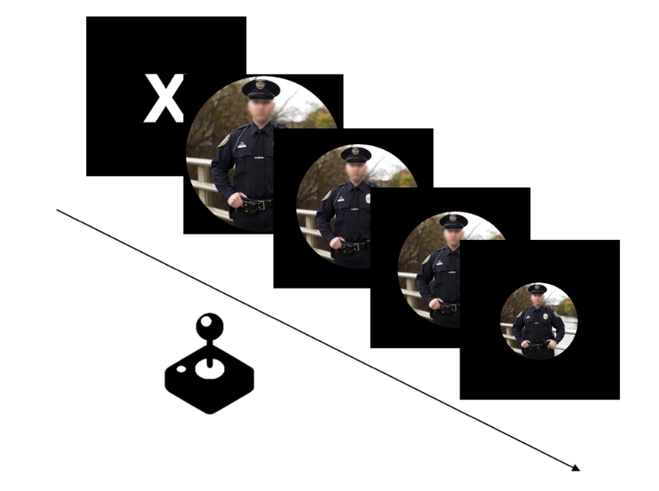
Response latency was indexed as the time in initial movement of the joystick in the correct direction (i.e., forward/away for avoid, backward/toward for approach). Participants completed a single block in which they either avoided circular and approached square targets or they avoided square and approached circular targets (block type was counterbalanced between participants). The critical block was preceded by an eight-trial practice block in which all targets contained neutral images (e.g., images of filing cabinets, paper towel rolls). The critical block involved 80 randomized trials including 20 avoid-police, 20 approach-police trials, 20 avoid non-police, and 20 approach-non-police trials. Following the AAT participants completed demographic questionnaires and were debriefed.
Results
Slow responses latencies (three interquartile ranges above the 75th percentile; Tukey, 1977) were excluded from analyses (n = 455, 2.21% of trials), resulting in 20,107 usable trials. One participant had zero trials remaining following exclusions, and data from one participant were excluded due to a priori criteria of all participants needing to have at least 50% of trials remaining after exclusions. The patterns of results do not differ when trials from the latter participant are included.
We used PROC GLIMMIX of SAS to regress approach and avoid response latencies in separate generalized linear mixed-effects models onto stimulus type (police vs. non-police) with random intercept and slopes within participants. The model would not converge with a random intercept for stimuli (Judd et al., 2012). Implying that civilians more readily flee police than non-police, participants avoided police stimuli more quickly than non-police stimuli, F(1,256) = 12.40, p < .001, ß = .21, b = 17.36, 95% CI [7.65, 27.07] (M_{police} = 731 ms, SE= 3.79; M_{non-police} = 748 ms, SE = 3.98; see Figure 2).
Figure 2
Mean AAT avoid latency by condition. Error bars represent ±1 SEM.
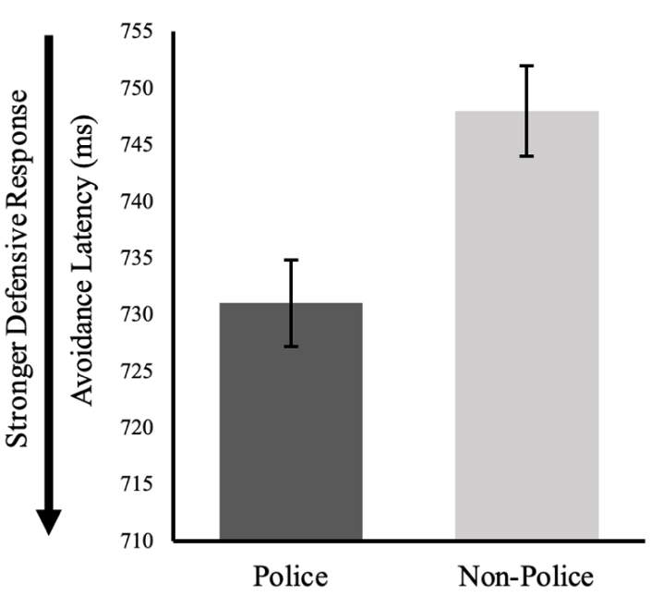
Participants did not differentially approach police than non-police stimuli, F(256) = 0.76, p = .384, ß = .054, b = 3.95, 95% CI [-5.11, 13.01] (M_{police} = 696 ms, SE = 3.62 M_{non-police} = 700 ms, SE = 3.74; see Supplemental Materials for graph of approach reaction times).
Discussion
In demonstrating that police officers relative to non-police facilitated an analog of a “flee” behavior, Study 1 provides initial evidence that police-threat responses manifest as behavioral responses geared toward bodily self-preservation. That we did not observe differences in approach behavior toward police and non-police was likely because none of our stimuli connoted positivity or contained appetitive content. That is, police as more threatening than non-police may have encouraged quicker avoid motivated behaviors. But if neither police nor non-police were more approach motivating, we would not expect to see difference in approach motivated behaviors (Heuer et al., 2007).
Study 2
Study 2 examines defensive motor freeze responses to police relative to non-police by assessing changes in postural sway. To maintain balance at standing rest, humans spontaneously engage muscles in their lower extremities. As a result, small excursions in center of pressure occur, manifesting as postural movements (i.e., spontaneous postural sway; Roelofs, 2017). As noted earlier, people evince diminished postural sway while viewing or anticipating physical threats. Study 2 participants viewed the same classes of stimuli as Study 1 while standing on a force plate which continuously sampled excursions in center of pressure (COP).
Materials and Methods
One-hundred twenty-six undergraduates at a large southeastern American university participated for partial course credit (M_{age} = 18.74, SD_{age} = 1.25; 92 women, 32 men, 2 other or unreported; 90 White, 10 Asian, 9 Black, 17 other or unreported; 35 Hispanic, 91 non-Hispanic). Our sample size was determined by the maximum number of participants that could be collected during the semester in which Study 2 was conducted and well-exceeded sample sizes in similar work assessing posturography as an index of defensive freezing (e.g., Azevedo et al., 2005, Bastos et al., 2016, Roelofs et al., 2010, and van Ast et al., 2021). A post hoc sensitivity analysis of the critical effect revealed an observed effect size greater than the predicted minimal detectable effect size assuming 80% power to detect that effect (Faul et al., 2007; Murayama et al., 2022).
The stimulus set for Study 2 was the same as that for Study 1 with five additional police and non-police images supplementing the original set (see Supplemental Materials for all stimuli). Additional images were added to reflect the blocked structure of Study 2 discussed in more detail below. Study 2 took place in a private room equipped with a height-adjustable monitor, a computer, and a custom-built 50.8×50.8 cm strain-gauge force platform. The force platform was outfitted with four load sensors and sampled at a rate of 83 Hz (1 sample/12 ms). During trials, excursions of center of pressure (COP) were continuously sampled. Participants stood on the force platform with their feet approximately 20 cm apart with arms positioned along their sides. At the onset of each session, the force platform was calibrated, and the monitor was adjusted to approximate eye level and stationed about 80 cm from the participant. Participants were instructed to passively view three 90-second blocks of images while standing still.
COP data is typically collected in a blocked format, where only one stimuli-type is presented in each block (e.g., Azevedo et al., 2005, Roelofs et al., 2010). Given this blocked format, to reduce the salience of police images as a focus of Study 2 (i.e., to make it less obvious that we were measuring reactions to police versus non-police), two separate blocks contained either civilian or uniformed non-police images and one block contained images from only police stimuli. Within blocks, participants viewed 30 continuously presented image trials (15 images were presented twice), with each trial lasting 3-seconds (with no intertrial interval). Each 3-second trial contained approximately 250 COP samples (i.e., 1 sample every 12 ms). Block order was counterbalanced between participants. To ensure that participants were attending to each image, they were told they would need to recall images at a later point during the study. Participants then completed demographic questionnaires and were debriefed.
Results
To prepare the COP data we removed outlier samples within trials (the result of high-frequency noise, defined as Z-scores greater than 4; van Ast et al., 2021) resulting in the exclusion of 0.47% of samples and filtered raw data using a 6-sample moving average filter (van Ast et al., 2021). As discussed earlier, diminished sway in the anterior-posterior (AP, front to back) plane reflects threat induced motor freezing in humans (Roelofs, 2010; van Ast et al., 2021). We therefore focused analyses on AP sway (see Supplemental Materials for exploratory analyses of sway in the mediolateral (ML) plane and net sway amplitude). Sway in the AP direction was quantified as the mean standard deviation (AP-SD) of COP within each 3-second trial (Roelofs et al., 2010). Figure 3a displays an example sway path for a single participant and Figure 3b displays the grand mean sway path of all participants.
Figure 3
Time course data from (a) representative participant and (b) a grand mean of all participants depicting continuous displacement of center of pressure.
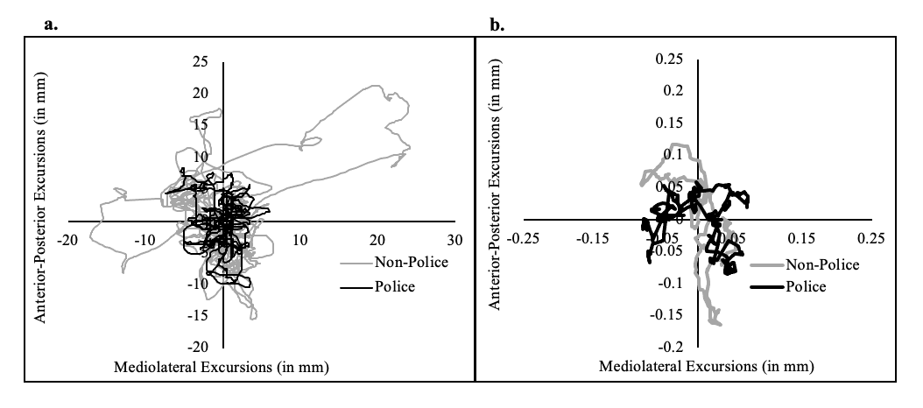
We used PROC GLIMMIX of SAS to regress AP-SD in a generalized linear mixed-effects models onto stimulus type (police vs. non-police) with random intercept and slopes within participants using a gamma probability distribution and log link (to accurately model nonnormal data as AP-SDs were positively [right] skewed; Ng & Cribbie, 2016). Models would not converge with a random intercept for stimuli. Suggesting that police evoke heightened defensive freeze responses among civilians, participants showed less variability in AP postural sway while viewing police compared to non-police, F(1,125) = 9.04, p = .003, ß = 0.27, b = 0.34 95% CI [0.091, 0.594, (M_{police} = 3.21, SE = 0.060; M_{non-police} = 3.55, SE = 0.053; see 4).
Figure 4
Mean SD in anterior-posterior plane (AP-SD) by condition. Error bars represent ±1 SEM.
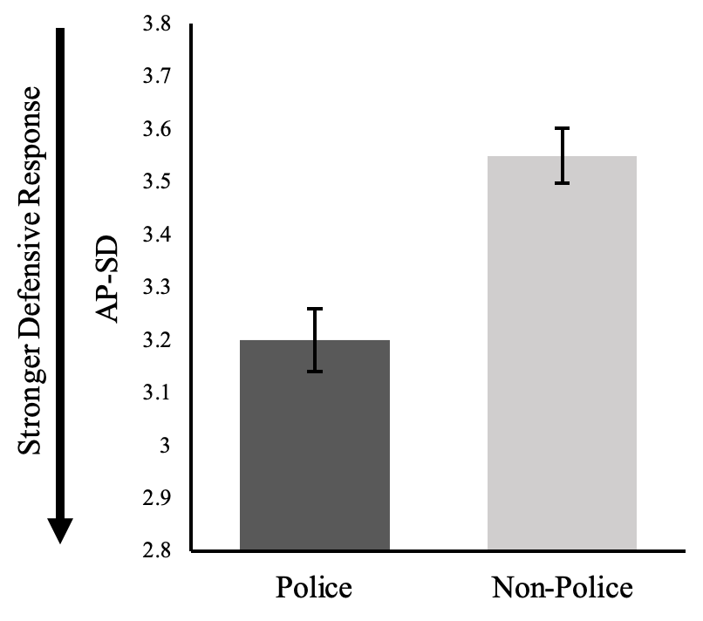
Discussion
The results from Study 2 converge with those from Study 1 to suggest that police evoke defensive behaviors—both active avoidance and defensive freezing—among civilians. Together these studies strongly imply that people are prepared to respond more defensively when exposed to the police than non-police. Study 3 further examines this question at the physiological level by using fEMG to index defensive preparations that occur in response to perceiving a threat.
Study 3
Study 3 examines a physiological index of defensive responding by utilizing fEMG and the startle eyeblink paradigm. The startle eyeblink paradigm uses an auditory probe to elicit a startle reflex characterized by an automatic contraction of the orbicularis oculi muscle surrounding the eye causing an eyeblink. Participants view image stimuli while electrodes measure the amplitude of the startle-induced eyeblink during a subset of stimuli. In Study 3 startle eyeblinks were measured during presentations of police and non-police stimuli.
Materials and Methods
Two-hundred eighteen undergraduates at a large southeastern American university participated for partial course credit (M_{age} = 18.89, SD_{age} = 1.53; female = 150, male = 68; 177 White, 22 Black, 13 Asian, 6 other or unknown; 57 Hispanic, 161 non-Hispanic). Our sample size was determined by the maximum number of participants that could be collected during the semester in which Study 3 was conducted and meets or exceeds sample sizes in prior work utilizing the startle eyeblink task (e.g., March et al., 2017; 2022). A post hoc sensitivity analysis of the critical effect revealed an observed effect size greater than the predicted minimal detectable effect size assuming 80% power to detect that effect (Faul et al., 2007; Murayama et al., 2022).
Participants were seated in an individual room equipped with a monitor and computer. Skin on the center of the forehead and below the left eye was lightly abraded and cleaned with alcohol to reduce impedance. Two 4-mm Ag-AgCl electrodes filled with electrode gel were then placed over the orbicularis oculi muscle below the left eye, and a ground was placed on the center of the forehead. Headphones were calibrated prior to each participant with a decibel meter. fEMG data were acquired with a BIOPAC MP160 system using an fEMG100D amplifier and AcqKnowledge 5.0 software (BIOPAC, Goleta, California) at a rate of 2000 Hz with an amplified gain of 5000 and notch (60 Hz) and band-pass filtered (HP = 10, LP = 500) online. Following convention, raw data were rectified, fully integrated, and averaged over 20 samples with the root mean square (Blumenthal et al., 2005).
Participants completed a single block of 90 trials in which they passively viewed police and non-police images. The stimulus set in Study 3 was identical to that of Study 1. Consistent with Study 2, to reduce the focus on police relative to non-police, thirty total trials involved police images and 60 involved non-police images (30 civilian + 30 uniformed non-police). Each trial began with a 1,000 ms centrally located fixation “X”, which was replaced by a 6,000 ms presentation of a police or non-police stimulus. On a subset of 27 critical trials (9 police, 18 non-police) a 100db, 50 ms white noise blast (i.e., the auditory probe) was delivered 2,000 to 4,000 ms after stimulus onset. An 8,000 to 12,000 ms intertrial blank screen followed each trial. Presentation order of both the images and noise probes were fully randomized to mitigate predictability. Following the startle eyeblink procedure, participants completed a demographic questionnaire and were debriefed.
Results
Data processing followed suggested protocols (e.g., Blumenthal et al., 2005; March et al., 2017, 2022). Twenty-nine participants were omitted due to non-responsiveness (i.e., no usable blinks), resulting in 189 usable participants. Individual trials were visually inspected and excluded if participants (1) blinked or cringed excessively (i.e., tensed the orbicularis oculi which precludes or obscures an eyeblink) during the baseline or (2) failed to blink following the probe (24.24%). This exclusion rate is in line with recent work using a similar startle-eyeblink design and exclusion criteria (March et al., 2017, 2022). Remaining trials were Z-scored within-person and blinks ±2.5 SD were excluded (2.31%). On each trial, startle eyeblink amplitude was calculated by subtracting the mean fEMG amplitude of the 50 ms preceding the noise-probe from the maximum amplitude within a 200 ms window following the probe.
Mean eyeblink amplitudes were regressed in a fixed effects repeated measures linear regression onto stimulus type. (Mixed-effects models with random intercepts and/or slopes within participants did not converge). Implying heightened physiological preparation to respond defensively to police than non-police, participants evinced larger startle eyeblink amplitudes to police (M_{t-score} = 49.85, SE =.25) than non-police images (M_{t-score} = 49.03, SE = .17, see Figure 5), F(1,180) = 7.42, p = .007, ß = 0.22, b = .82, 95% CI [0.23, 1.41].
Figure 5
Mean eyeblink amplitude by condition. Error bars represent ±1 SEM.
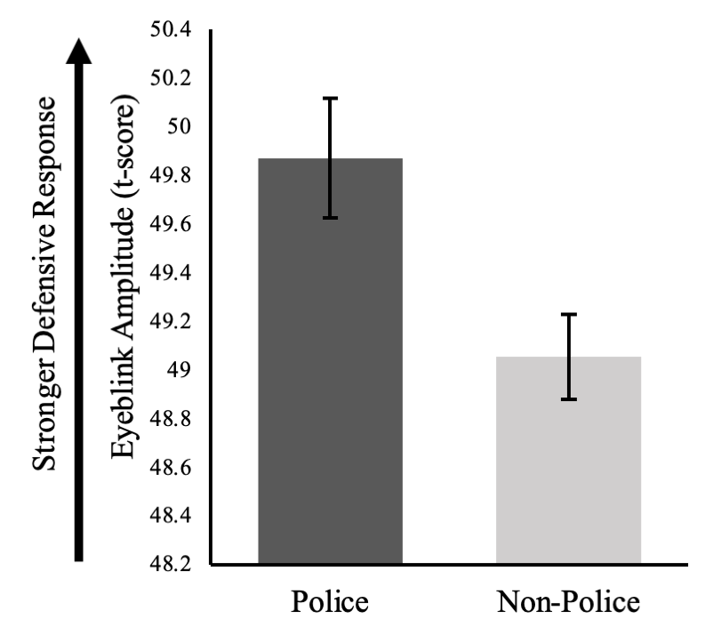
Discussion
Implying that police than non-police evoke relatively heightened defensive physiological responses, startle eyeblinks were larger during presentations of police compared to non-police images. These findings converge with those from Studies 1 and 2 to suggest that police compared to non-police evoke a wide range of defensive responses.
General Discussion
In the United States, interactions between police officers and civilians can be inherently dangerous from both the police and civilian perspective. Despite this, research on the role of danger and related responses during police-civilian interactions has almost exclusively focused on the perspective of police officers and the hypothesized role of threat in officer’s decisions. The current work expands this viewpoint to suggest that people may evince defensive behaviors towards the police as a source of threat. Three studies, each using a unique measure of defensive responding, consistently found heightened defensive responses to police than non-police. Study 1 found that people more quickly avoid police than non-police. Study 2 showed that people display heightened motor freeze responses to police than non-police. Study 3 demonstrated that people experience heightened defensive preparation to police than non-police. Together, these findings imply that (at least in the United States) civilian’s initial behaviors when encountering police may sometimes be defensively driven by threat. In the remaining discussion, we consider what it means for civilian behaviors during encounters with police officers to sometimes be considered reflexively defensive.
Implications of Police-Threat Associations for Civilian Attitudes and Behaviors
Implications of Police-Threat Associations on in-the-moment Behaviors
How might the defensive responses evinced in the current work unfold in a real-world police-civilian interaction? In light of our data, such an encounter may evoke in the civilian automatic defense as the civilian prepares to respond to a potential threat. For example, the officer’s orders (i.e., to “lay on the ground”, “put your hands up”) may promote a behavioral pause (i.e., freeze) or flinch (i.e., preparation to flee) as the civilian considers whether such actions increase their likelihood of experiencing physical harm. Automatic threat-associations and responses are particularly likely to manifest as behavior under circumstances of limited opportunity to engage control (Fazio, 1990). And the reflexive nature of defensive behaviors (Mobbs et al., 2020) might reduce an already limited initial opportunity to engage controlled processing (March et al., 2018). Consequently, police-threat associations may evoke defensive behaviors that are difficult to control or inhibit during an initial split-second expression.
The effects observed in the current work were on a magnitude of milliseconds, millimeters, and millivolts. Yet in situations where people are making split-second decisions—such as in police-civilian encounters—small effects can have large ramifications. This is especially true when initial reactions can be instigated within hundreds of milliseconds. A defensive flinch or recoil exhibited by a civilian, for example, could be rapidly misinterpreted by an officer as an act of aggression, and in turn provoke police aggression. Similarly, a hesitation or a freeze for any amount of time could be quickly misconstrued by an officer as a non-compliant or hostile act. This is to say that during police-civilian encounters, threat-driven responses of any magnitude may manifest in a cascade of recursive and mutually defensive behaviors. For example, (1) a civilian may evince a behavioral manifestation of a police-threat association (e.g., one of the defensive responses outlined above), which may (2) cue the officer to perceive the civilian as a threat, which in turn may (3) trigger a deadly cascade of mutually defensive behaviors (such as defensive aggression). Solutions to these issues are assuredly complex. Simply asking officers to not react to what they see as a threatening behavior (e.g., flinch, non-compliance) is impractical and potentially dangerous to the officer. But in the same light, expecting control of automatic threat processes among civilians is likewise a difficult task. As we speak to in a following section, focusing on contextual features known to provoke defensive responses might be one avenue for mitigating this harmful process before it begins. Further, it is important to consider that certain civilian behaviors may sometimes be caused by innate (i.e., automatic or reflexive) defensive responding has fundamental implications for how legal institutions view and litigate civilian non-compliance (as police behaviors in these situations are often viewed; O’Flaherty & Sethi, 2019; Rosenthal, 2020). Here the idea is that non-compliance might (in some circumstances) stem from reflexive survival motivations that are difficult to control in the moment. If so, what may initially look to an officer and court like non-compliance may ultimately be understood as defensive. Our findings imply a need to genuinely consider this idea.
Last, automatic defensive outcomes during face-to-face interactions with police may be particularly likely to manifest among groups who have stronger-police threat associations. Consider that Black Americans both face more police contact and are disproportionate victims of police violence (Crutchfield et al., 2012; DeGue et al., 2016; Edwards et al., 2019; Schimmack & Carlsson, 2020). Personal or vicarious experiences of police-violence likely contribute to commensurately heightened police-threat associations via direct or vicarious fear-conditioning (Olsson & Phelps, 2007) which encourage defensive behaviors upon next encountering an officer. This combination of factors may comprise a deadly mixture that manifests in the reality of Black (and brown) Americans experiencing disproportionate police violence. We further detail implications of the current work for racial bias in policing throughout the remainder of the General Discussion.

Implications of Police-Threat Associations for Attitudes and Decision Making.
In the current work we measured defensive responses during “direct” exposure to police exemplars (i.e., what has been termed in the threat literature as a “post-encounter threat response”; Mobbs et al., 2020). Yet police-danger associations and defensive responses might also affect several other downstream attitudes and behaviors absent or prior to a police presence. Our previous work, for example, demonstrates that automatic police-threat attitudes predict more negative explicit attitudes of the police over and above automatic police-negative evaluations (Olivett & March, 2021). Meaning, police-threat associations are a negative influence on explicit attitudes of the police. Negative summary attitudes may in turn foment distrust or passive avoidance of the police.
Although the explicit attitudes measured by Olivett & March (2021) captured general positive-to-negative views of the police, automatic police-danger evaluations may also relate to more specific attitudes about policing and police reform. Supporting this idea, self-reported emotional fear of the police predicts support for defunding the police as well as intentions to engage in defensive legal socialization (i.e., having “the talk” about the police with one’s children; Pickett et al., 2022). Other attitudinal and behavioral implications of police-danger associations remain unexplored. Future work could investigate the possibility that these associations erode trust in the police or facilitate passive avoidance of the police such as hesitance to report a crime. Almost a third of American survey respondents report that they would rather be robbed or burglarized than be questioned by police (45% among Black respondents; Pickett et al., 2022). This may suggest that for some people, police-threat associations outweigh other danger perceptions manifesting as a reluctance to call the police for help when oneself or someone else is in danger.
Consider, for example, a Black mother who was recently interviewed after hearing gunfire near her Ohio home and soon after discovered bullet holes in her son’s car. Despite wanting someone to investigate the damage, she passed on reporting it to the police, noting “It’s very scary... I’m not calling the police, because they could do anything, and it could go bad real fast” (Ockerman, 2021). Another interviewee—who had recently been subjected to police violence while attending a protest—recalled declining to call the police from inside her home while it was actively being broken in to. Objects associated with threat typically come to be avoided as people work to avoid putting themselves in a potentially harmful situation (LeDoux et al., 2017). The same is true for people who come to be associated with threat. Distrust and avoidance of the police at this magnitude is conceivably underpinned by defense motives driven by a police-threat association.
Implications for Policing Practices
An advantage to approaching police “shoot” decisions as a threat response and a consequence of defensive behaviors is that it opens the door for interventions focused on disrupting threat misperceptions (e.g., Fair & Impartial Policing, 2019). The current work analogously suggests that tailoring police-civilian interactions toward reducing threat responses among both police and civilians may in turn reduce undue use of force. For example, research on defensive responding describes contextual features (e.g., speed, direction, imminence, and potency of the threat) that collectively determine whether and how defensive behaviors unfold during encounters with a threat. Contextual features describing how an officer approaches a civilian (and vice versa) may modulate the expression of a threat responses. Indeed, unexpected and rapidly (versus expected or more slowly) approaching threats elicit distinct reflexive defensive behaviors (as opposed to slower and more planned forms of behavioral threat avoidance; Qi et al, 2018). Thus, policing practices that involve surprise and rapid approach—such as no-knock warrants—might be particularly prone to evoke reflexive defensive behaviors among civilians.3 Similarly, humans are more prone to stimulus-response driven (e.g., reflexive defense) versus controlled behaviors under circumstances of acute stress (Hermans et al., 2014). Policing practices that minimize acute stress—such as the use of de-escalation techniques—might therefore curtail reflexive defensive responses among civilians.
Implications for Racial Bias in Policing
In the United States, members of marginalized groups—particularly Black and Hispanic men—are more likely to experience contact with the police (Crutchfield et al., 2012). Consequently, Black and Brown individuals are more frequently exposed to situations in which defensive responses to police may be activated. Consider, for example, racial bias in traffic stops—Black and Hispanic individuals are both more likely to be pulled over by the police and more likely to be subjected to vehicle searches (Pierson et al., 2020). Racial biases emerge in how police interact with civilians during traffic stops which could be linked to the types of practices we mention above that may provoke defensive responses. Body camera footage demonstrates that police officers speak more disrespectfully (Voigt et al., 2017) and use a harsher tone when interacting with Black compared to White civilians, which in turn erodes trust in the police (Camp et al., 2021). Due to this base-rate disparity, individuals from certain racial and ethnic groups may be more sensitive to, or exhibit larger, defensive responses to the police. Indirectly supporting this idea is evidence that Black Americans self-report significantly greater personal and vicarious emotional fear of police than non-Black Americans (Pickett et al., 2022). Although a strength of the current work was that the racial and ethnic makeup of our sample was roughly representative of the U.S. population (U.S. Census), we lacked power to test for moderation by race/ethnicity. Here we examined only a small slice of civilians. We see this as an important direction for future work on the role of threat in police-civilian encounters.
Another implication is the possibility of racial bias in police officers’ evaluations of defensive behaviors exhibited by civilians. That is, automatic defensive responses evinced by Black individuals might be differentially perceived as threatening to police officers, further exacerbating racial bias in police use of force. Black men are perceived as more threatening and dangerous than are White men (March et al., 2021, 2022). A bias in threat-associations (i.e., the likelihood of the activation of a threat association to Black versus other raced individuals) is likely to affect how officers perceive ambiguously threatening behaviors. Meaning, if Black American men are perceived as more dangerous, behaviors exhibited by Black men are more likely to be perceived as a threat to the officer. This will likely manifest in the many ways officers interact with non-compliant civilians. For example, in 2022, Black and Brown individuals fleeing the police were more likely to be killed than were White individuals fleeing the police (Mapping Police Violence). Research on racial bias in police use of force may need to consider how police differently perceive defensive responding among people from different racial groups.
Limitations and Other Further Directions
Although the current results highlight quick and automatic responses, they do not speak to when, in what combination, or for how long defensive behaviors occur when civilians interact with police officers in real-life. Rather, our work suggests that defensive responses to police can occur, and, due to their automatic nature, that they may be the initial response when police officers are perceived as threats. Yet the current work cannot speak to what specific defensive responses (or combination of responses) occur, or for how long they continue during a given police-civilian interaction. Various contextual and personal motivational factors outlined above might influence responses, but these remain unaddressed by our studies. Future work can examine these possibilities by systematically varying contextual features such as behavioral affordances (including opportunity to control defensive responses), imminence of police exemplars, and stress induction, or by examining defensive responses in more dynamic environments such as virtual reality during a prolonged encounter.
Similarly, future work should aim to elucidate person-level psychological or experiential antecedents that may predispose heightened defensive responses to the police. Noted above, one way in which police-danger associations may be learned is through direct or vicarious fear conditioning. Thus, the extent to which an individual directly experiences or witnesses violent encounters with police may tune their sensitivity to exhibiting and/or the magnitude of their defensive responses to police. One prevalent source of vicarious exposure to police violence might be through news and social media. Future research could examine if upticks in acts of police violence and associated media coverage relate to civilians’ likelihood of exhibiting defensive responses to the police. If officers interpret defensive behaviors as aggressive, civilians’ heightened responses may in turn exacerbate negative outcomes during interactions with police. Meaning, much like mutually defense behaviors during police-civilian interactions may activate and operate cyclically, publicly viewable acts of police violence and civilians’ increased likelihood of responding defensively might feed into one another over time.
Moreover, it is possible that these and other experiences may interact with dispositional or environmentally tuned factors that alter defensive responding to the police. The formation of police-danger associations as a result of experiencing or witnessing police violence may be especially likely among individuals who experience such events more frequently (e.g., members of racial groups that experience disproportionate police violence) or are high in traits such as physical threat sensitivity or emotional instability. In other words, individuals who are on average more sensitive to perceiving threats in any given context are perhaps more likely to develop police-threat associations as a consequence of witnessing or experiencing police violence. This may exacerbate the patterns described above.
Last, each study in the present work examines a distinct defensive response to the police and all studies cohered to consistently show heightened defensive responding to police relative to non-police. Yet, although findings from each study conceptually replicate one another, the present package of studies lacks a direct replication. Direct replications would grant further confidence in each individual finding (i.e., speeded avoidance, enhanced freeze, potentiated startle reflex to police). Nonetheless, the consistency found in our conceptual replications serves to confirm that the theoretical idea behind our findings (i.e., that civilians respond to the police defensively) is valid. Future direct replications can extend the current findings by also exploring experiential and personality antecedents to defensive behaviors and other possible effects of police-threat associations on subsequent judgments and behaviors.
Conclusions
The current work examined civilians’ defensive bodily responses to police officers. Across three studies we demonstrate that people (1) actively avoid police, (2) defensively freeze in response to police, and (3) evince heightened defensive preparation to the to police.

References

Azevedo T. M, Volchan, E., Imbiriba, L. A., Rodrigues, E. C., Oliveira, J. M., Oliveira, L. F.,
Lutterbach, L., G., & Vargas, C. D. (2005). A freezing-like posture to pictures of mutilation. Psychophysiology, 42, 255—260.

Bastos, A. F., Vieira, A. S., Oliveira, J. M., Oliveira, L., Pereira, M. G., Figueira, I., Erthal,
F. S. & Volchan, E. (2016). Stop or move: Defensive strategies in humans. Behavioural Brain Research, 302, 252—262.

Blumenthal, T. D., Cuthbert, B. N., Filion, D. L., Hackley, S., Lipp, O. V., & Van Boxtel, A.
(2005). Committee report: Guidelines for human startle eyeblink electromyographic studies. Psychophysiology, 42, 1-15.

Camp, N. P., Voigt, R., Jurafsky, D., & Eberhardt, J. L. (2021). The thin blue waveform:
Racial disparities in officer prosody undermine institutional trust in the police. Journal of Personality and Social Psychology, 121, 1157—1171.

Campbell, F. & Valera, P. (2020). “The only thing new is the cameras”: A study of U.S.
college students’ perceptions of police violence on social media. Journal of Black Studies, 51, 654—670

Chen, M., & Bargh, J. A. (1999). Consequences of automatic evaluation: Immediate
behavioral predispositions to approach or avoid the stimulus. Personality and Social Psychology Bulletin, 25, 215–224.

Correll, J., Park, B., Judd, C. M., & Wittenbrink, B. (2002). The police officer’s dilemma:
Using ethnicity to disambiguate potentially threatening individuals. Journal of Personality and Social Psychology., 83, 1314–1329.

Correll, J., Park, B., Judd, C. M., Wittenbrink, B., Sadler, M. S., & Kreese, T. (2007). Across
the thin blue line: Police officers and racial bias in the decision to shoot. Journal of Personality and Social Psychology, 92, 1006–1023.

Devine, P. G., Plant, E. A., Amodio, D. M., Harmon-Jones, E., & Vance, S. L. (2002). The
regulation of explicit and implicit race bias: the role of motivations to respond without
prejudice. Journal of Personality and Social Psychology, 82, 835.

DeGue, S., Fowler, K. A., & Calkins, C. (2016). Deaths due to use of lethal force by law
enforcement: Findings from the national violent death reporting system, 17 U.S. States, 2009–2012. American Journal of Preventive Medicine, 51, S173–S187.

Edwards, F., Lee, H., & Esposito, M. (2019). Risk of being killed by police use of force in
the United States by age, race-ethnicity, and sex. Proceedings of the National Academy of Sciences USA, 116, 16793–16798.

Fair & Impartial Policing. Retrieved from: https://fipolicing.com/.

Fanselow, M. S., & Lester, L. S. (1988). A functional behavioristic approach to aversively
motivated behavior: Predatory imminence as a determinant of the topography of defensive behavior. In R. C. Bolles & M. D. Beecher (Eds.), Evolution and learning (pp. 185–212). Lawrence Erlbaum Associates, Inc.

Faul, F., Erdfelder, E., Lang, A.-G., and Buchner, A. (2007). G*Power 3: A flexible statistical
power analysis for the social, behavioral, and biomedical sciences. Behavior Research Methods, 39, 175—191.

Fazio, R. H. (1990). Multiple processes by which attitudes guide behavior: The mode model
as an integrative framework. Advances in Experimental Social Psychology, 23, 75—90.

Gladwin, T. E., Hashemi, M. H., van Ast, V., & Roelofs, K. (2016). Ready and waiting:
Freezing as active action preparation under threat. Neuroscience Letters, 619, 182—188.

Grillon, C., Ameli, R., Woods, S. W., Merikangas, K., & Davis, M. (1991). Fear-potentiated
startle in humans: Effects of anticipatory anxiety on the acoustic blink reflex. Psychophysiology, 28, 558—595.

Hamilton, D. L., & Sherman, J. W. (1994). Stereotypes. In R. S. Wyer, Jr. & T. K. Srull
(Eds.), Handbook of social cognition: Basic processes; Applications (pp. 1–68). Lawrence Erlbaum Associates, Inc.

Hashemi, M. M., Gladwin, T. E., de Valk, N. M., Zhang, W., Kaldewaij, R., van Ast, V.,
Koch, S. B., Klumpers, F., & Roelofs, K. (2019). Neural dynamics of shooting decisions and the switch from freeze to fight. Nature Scientific Reports, 9, 1—10.

Hermans, E. J., Henckens, M. J. A. G., Joëls, M., & Fernández, G. (2014). Dynamic
adaptation of large-scale brain networks in response to acute stressors. Trends in Neuroscience, 37, 304—314.

Heuer, K., Rinck, M., & Becker, E. S. (2007). Avoidance of emotional facial expressions in
social anxiety: The approach-avoidance task. Behaviour Research and Therapy, 45, 2990—3001.

Judd, C. M., Westfall, J., & Kenny, D. A. (2012). Treating stimuli as a random factor in social
psychology: a new and comprehensive solution to a pervasive but largely ignored problem. Journal of personality and social psychology, 103(1), 54.

Kahn, K. B. & Davies, P. G. (2011). Differentially dangerous? Phenotypic racial
stereotypicality increases implicit bias among ingroup and outgroup members. Group Processes & Intergroup relations, 14, 569—580.

Klein, A. M., Becker, E. S., & Rinck, M. (2011). Approach and avoidance tendencies in
spider fearful children: The approach-avoidance task. Journal of Child and Family Studies, 20, 224—231.

Lang, P. J., Bradley, M. M., & Cuthbert, B. N. (1990). Emotion, attention, and the startle
reflex. Psychological Review, 97, 377—395.

LeDoux, J. E., Moscarello, J., Sears, R., & Campese, V. (2017). The birth, death, and
resurrection of avoidance: A reconceptualization of a troubled paradigm. Molecular Psychiatry, 22, 24—36.

LeDoux, J. E., & Pine, D. S. (2016). Using neuroscience to understand fear and anxiety: A two
system framework. American Journal of Psychiatry, 173, 1083–1093.

Lo, S. & Andrews, S. (2015). To transform or not to transform: Using generalized linear mixed
models to analyze reaction time data. Frontiers in Psychology, 6. https://doi.org/10.3389/fpsyg.2015.01171

Löw, A., Lang, P. J., Smith, J. C., & Bradley, M. M. (2008). Both predator and prey:
Emotional arousal in threat and reward. Psychological Science, 19, 865—873.

Löw, A., Wymar, M., & Hamm, A. O. (2015). When threat is near, get out of here: Dynamics
of defensive behavior during freezing and active avoidance. Psychological Science, 26, 1706–1716.

Mapping Police Violence. Retrieved from: https://mappingpoliceviolence.us/.

March, D. S. (2022). Perceiving danger from within: Black Americans associate black men
with physical threat. Social Psychological and Personality Science, 0(0).

March, D. S., Gaertner, L., & Olson, M. A. (2022). On the automatic nature of threat:
Physiological and evaluative reactions to survival-threats outside conscious perception. Affective Science, 3, 135—144.

March, D. S., Gaertner, L., & Olson, M. A. (2021). Danger or dislike: Distinguishing threat
from negative valence as sources of automatic anti-black bias. Journal of Personality and Social Psychology, 121, 984—1004.

March, D. S., Gaertner, L., & Olson, M. A. (2018a). On the prioritized processing of threat in
a dual implicit process model of evaluation. Psychological Inquiry, 19, 1—13.

March, D. S., Gaertner, L., & Olson, M. A. (2018b). Clarifying the explanatory scope of the
dual implicit process model. Psychological Inquiry, 19, 38—43.

March, D. S., Gaertner, L., & Olson, M. A. (2017). In harm’s way: On preferential response
to threatening stimuli. Personality and Social Psychology Bulletin, 43, 1519—1529.

March, D. S. & Graham, R. (2015). Exploring implicit ingroup and outgroup bias toward Hispanics. Group Processes and Intergroup Relations, 18, 89-103. Doi.org/10.1177/1368430214542256

Marsh, A. A., Kleck, R. E., & Ambady, N. (2005). The effects of fear and anger facial
expressions on approach- and avoidance-related behaviors. Emotion, 5, 119—124.

Mobbs, D., Headley, D. B., Ding, W., & Dayan, P. (2020). Space, time, and fear: Survival
computations along defensive circuits. Trends in Cognitive Sciences, 24, 228—241.

Mobbs, D., Petrovic, P., Marchant, J. L., Hassabis, D., Weiskopf, N., Seymour, B., Dolan, R.,
J., & Frith, C. D. (2007). When fear is near: Threat imminence elicits prefrontal-periaqueductal gray shifts in humans. Science, 317, 1079—1083.

Murayama, K., Usami, S., & Sakaki, M. (2022). Summary-statistics-based power analysis: A
new and practical method to determine sample size for mixed-effects modeling. Psychological Methods, 27(6), 1014–1038. https://doi.org/10.1037/met0000330.

Ng, V.K., Cribbie, R.A. (2017).Using the Gamma Generalized Linear Model for Modeling Continuous, Skewed and Heteroscedastic Outcomes in Psychology. Current Psychology, 36, 225–235. https://doi.org/10.1007/s12144-015-9404-0

Ockerman, E. (2021, May). What if we just stopped calling the cops? Vice News.
https://www.vice.com/en/article/wx5n4z/what-if-we-just-stopped-calling-the-cops

O’Flaherty, B. & Sethi, R. (2019, May 1). How fear contributes to cops’ use of deadly force.
The Marshall Project. https://www.themarshallproject.org/2019/05/01/can-understanding-fear-mitigate-police-violence

Olivett, V. J. & March, D. S. (2021). White civilians’ implicit danger evaluations of police
officers underlies explicit perception of police. Cognitive Research: Principles and Implications, 6, 1—10.

Olsson, A., Nearing, K. I., & Phelps, E. A. (2007). Learning fears by observing others: The
neural systems of social fear transmission. Social Cognitive and Affective Neuroscience, 2, 3—11.

Olsson, A. & Phelps, E. A. (2004). Learned fear of “unseen” faces after pavlovian,
observational, and instructed fear. Psychological Science, 15, 822—828.

Olsson, A., & Phelps, E. A. (2007). Social learning of fear. Nature Neuroscience, 10, 1095—
1102.

Pickett, J. T., Graham, A., & Cullen, F. T. (2022). The American racial divide in fear of the
police. Criminology, 60(2), 291—320.

Pierson, E., Simoiu, C., Overgoor, J., Corbett-Davies, S., Jenson, D., Shoemaker, A.,
Ramachandran, V., Barghouty, P., Phillips, C., Shroff, R., & Goel, S. (2020). A large-scale analysis of racial disparities in police stops across the United States. Nature Human Behavior, 4, 736—745.

Qi, S. Hassabis, D., Sun, J., Guo, F., Daw, N., & Mobbs, D. (2018). How cognitive and
reactive fear circuits optimize escape decision in humans. Proceedings of the National Academy of Sciences, 115, 3186—3191.

Roelofs, K. (2017). Freeze for action: Neurobiological mechanisms in animal and human
freezing. Phil. Trans. R. Soc. B, 372, 1—10.

Roelofs, K. & Dayan, P. (2022). Freezing revisited: Coordinated autonomic and central
optimization of threat coping. Nature Reviews Neuroscience, 23, 568—580.

Roelofs, K., Hagenaars, M. A. Stins, J. (2010). Facing freeze: Social threat induces bodily
freeze in humans. Psychological Science, 11, 1575—1581.

Rosenthal, L. (2020, June 12). Police violence is mostly rooted in fear. Ignoring that makes
reform harder. NBC News. https://www.nbcnews.com/think/opinion/police-violence-mostly-rooted-fear-ignoring-makes-reform-harder-ncna1230266

Schielzeth, H, Dingemanse, NJ, Nakagawa, S, et al. Robustness of linear mixed-effects models to violations of distributional assumptions. Methods Ecol Evol. 2020; 11: 1141– 1152. https://doi.org/10.1111/2041-210X.13434

Schimmack, U. & Carlsson, R. (2020). Young, unarmed nonsuicidal male victims of fatal use
of force are 13 times more likely to be Black than White. Proceedings of the National Academy of Sciences USA, 117, 1262.

Tukey, J. W. (1977). Exploratory data analysis. Reading: Addison-Wesley.

U.S. Census. Retrieved from: https://www.census.gov/quickfacts/fact/table/US/PST04522.

van Ast, V. A., Klumpers, F., Grasman, R. P. P. P., Krypotos, A. M., & Roelofs, K. (2021).
Postural freezing relates to startle potentiation in a human fear conditioning paradigm. Psychophysiology, 59, 1—20.

Van Zandt, T., & Ratcliff, R. (1995) Statistical mimicking of reaction time data: Single-process models, parameter variability, and mixtures. Psychonomic Bulletin & Review 2, 20–54. https://doi.org/10.3758/BF03214411

Voigt, R., Camp, N. P., Prabhakaran, V., Hamilton, W. L., Hetey, R. C., Griffiths, C. M.,
Jurgens, D., Jurafsky, D., & Eberhardt, J. L. (2017). Language from police body camera footage shows racial disparities in officer respect. Proceedings of the National Academy of Sciences USA, 114, 6521—6526.

Importantly, although some reactions may be driven by threat responses, it is unlikely that all instances of police use of force stem from automatic threat processes. Delayed and more controlled decisions (e.g., applying a chokehold or knee-to-the-neck of a suspect) are likely the product of more controlled processes (Devine, 1989).
Analogous models with natural-logged reaction times (Lo & Andrews, 2015; Van Zandt & Ratcliff, 1995) yielded the same statistical conclusions and directions of effects for both approach and avoid responses. Indeed, log transformed data is uninterpretable and mixed-effects models are robust to normality violations (Schielzeth et al., 2020). As the transformed data provide the same conclusions, the untransformed data was retained.
See Supplemental Materials for exploratory analyses comparing police to distinct categories of civilian and uniformed non-police, respectively, for this study as well as for Studies 2 and 3.
Analogous models with Gaussian (i.e., normal) distributions and raw or natural-logged reaction times, respectively, yielded the same statistical conclusions and directions of effects.
Due to experimenter error, data on trial-level stimulus information is missing for ten participants. Condition information remained (and stimulus-level effects are not utilized in the analysis). Statistical conclusions and directions of effects remained consistent when excluding these participants.
Notably, our work does not contend that all instances of arrest non-compliance stem from automatic threat processes. As we mentioned earlier, controlled processes—such as knowledge of guilt or forecasting of potential legal repercussions—may contribute to non-compliant behavior.
3 The element of surprise is necessary for certain instances of arrest or confrontation, especially when suspects are believed to be dangerous. We are not suggesting that policing techniques that utilize surprise should be eliminated.

